# MUSICANO



***A Project Report submitted in partial fulfillment of the requirements for the award of the degree of***

## Bachelor of Computer Application

### By

|  |  |
| --- | --- |
| **Mr. Sagar Gahlot** | **(174200134)** |
| **Ms. Kratika Agrawal** | **(174200078)** |
| **Mr. Rishabh Sharma** | **(174200129)** |
| **Mr. Sachin Saxena** | **(174200132)** |
| **Mr. Satyam Kushwah** | **(174200142)** |

Under the Guidance of

**Mr. Anuj Mangal (Assistant Professor)**

Department of Computer Engineering & Applications

**Institute of Engineering & Technology**

**GLA University Mathura- 281406, INDIA**

**May, 2019**

**Department of Computer Engineering and Applications GLA University, Mathura**

**17 km. Stone NH#2, Mathura-Delhi Road,**

**P.O. – Chaumuhan, Mathura – 281406**

**U.P (India)**

**Declaration**

We hereby declare that the work which is being presented in the B.C.A. Project **“MUSICANO”**, in partial fulfillment of the requirements for the award of the ***Bachelor of Computer Applications*** and submitted to the Department of Computer Engineering and Applications of GLA University, Mathura, is an authentic record of our own work carried under the supervision of **Mr. Anuj Mangal, Assistant Professor of Computer Engineering Department.**

The contents of this project report, in full or in parts, have not been submitted to any other institute or university for the award of any degree.

|  |  |  |
| --- | --- | --- |
| Sagar Gahlot (174200134) |  | Kratika Agrawal (174200078) |
| Rishabh Sharma (174200129) |  | Sachin Saxena (174200132) |
| Satyam Kushwah (174200142) |  |  |
|  | **Certificate** |  |

This is to certify that the above statements made by the candidates are correct to the best of my/our knowledge and belief.

#### Project Supervisor Date:

(Mr. Anuj Mangal)

#### Project Incharge Program Coordinator Head of Department

**(Mr. Dhirendra Prasad Yadav) (Mr. Narendra Mohan) (Prof. Anand Singh Jalal)**

**ACKNOWLEDGEMENT**

The satisfaction which accompanies the successful completion of the project, is incomplete without the mention of a few names. We take this opportunity to acknowledge the efforts of the many individuals who helped us to make this project possible.

Firstly we would like to express our heartfelt appreciation and gratitude to our project guide **Mr. Anuj Mangal, Assistant Professor, Computer Engineering Department.** His vision and execution aimed at creating a structure, definition and realism around the project and fostered the ideal environment for us to learn and do. This project is a result of his teaching, encouragement and inputs in the numerous meetings he had with us, despite his busy schedule.

We would also like to extend our immense gratitude to respected Head of Department

**Prof. Anand Singh Jalal and Program Coordinator Mr. Narendra Mohan** who allowed us to choose the topic for our dissertation.

The experience was novel one and we would like to thank all the people, who have lent their valuable time for the completion of the report. Without their consideration it would have been difficult to complete the report.

|  |  |
| --- | --- |
| Mr. Sagar Gahlot | (174200134) |
| Ms. Kratika Agrawal | (174200078) |
| Mr. Rishabh Sharma | (174200129) |
| Ms. Sachin Saxena | (174200132) |
| Ms. Satyam Kushwah | (174200142) |

*MUSICANO is the site which help the students to learn music at their home or wherever they want to learn music this site make their time efficient. It can be assessable by any beginners. Through this website beginners can get the knowledge of the interested instrument and can learn it very easily. In this website there is an interaction of beginner with the artists if they learns and performs good.*

*This website will also keep track on uploaded videos. They will be uploaded on the profile of the beginner by themselves, if artist finds it good he will be happy to interact with them , with the help of this information many beginners can learn the interesting instrument of their will .This website will help a lot of musically sounded people.*

*There are 3 peoples who can access:*

1. *Beginner*
2. *Artist*
3. *Admin*

*Admin can change , modify, delete he have all the access over the site.*

*Information uploaded will be beneficial for all. Uploaded videos will be seen by all the users and beginners on the site best way to show cast your talent and grow up your hidden talent.*

|  |  |
| --- | --- |
| **Topic**  Certificate  Acknowledgement | **Pg.no.**  ii  iii |
| List of Tables | vii |
| List of Figures | viii |
| Chapter1 Introduction | 1 |
| 1.1 Overview &Motivation | 1 |
| 1.2 Objectives | 2 |
| 1.3 Organization of Project Report | 2 |
| Chapter 2 Software Requirement Analysis | 3 |
| 2.1 Requirement Analysis | 3 |
| 2.1.1 Hardware Requirement | 4 |
| 2.1.2 Software Requirement | 4 |
| 2.1.3 Tools and Technologies | 4 |
| 2.2 Feasibility Study | 5 |
| 2.2.1 Technical Feasibility | 5 |
| 2.2.2 Operational Feasibility | 6 |
| 2.2.3 Economical Feasibility | 7 |
| 2.3 Analysis | 7 |
| 2.4 Summary of Modules | 8 |
| Chapter 3 Software Design | 9 |
| 3.1 DFD | 10 |
| DFD Level 0 | 11 |
| DFD Level 1 | 11 |
| DFD Level 2 process 3 | 11 |
| DFD Level 2 process 6 | 12 |
| 3.2 ER | 13 |
| ER Diagram | 14 |
| 3.3 Database Design | 15 |
| Chapter 4 Implementation & User Interface | 18 |

|  |  |
| --- | --- |
| Chapter 5 Software Testing | 27 |
| 5.1 Testing | 27 |
| 5.2 Objectives of Software Testing | 27 |
| 5.3 Principles of Software Testing | 28 |
| 5.3.1 White Box Testing | 28 |
| 5.3.2 Black Box Testing | 28 |
| 5.4 Testing Fundamentals | 29 |
| 5.5 Testing Information | 29 |
| Conclusion | 30 |
| References | 31 |

|  |  |  |  |
| --- | --- | --- | --- |
| **S.No.** | **Table Name** | **Table No.** | **Page** |
| **1** | Artist Login | Table 3.1 | 15 |
| **2** | Beginner Login | Table 3.2 | 16 |
| **3** | Admin Login | Table 3.3 | 16 |
| **4** | Chat Room | Table 3.4 | 16 |
| **5** | Upload Videos | Table 3.5 | 17 |

|  |  |  |  |
| --- | --- | --- | --- |
| **S.No.** | **Figure Name** | **Fig.No.** | **Page** |
| **1** | Data Flow Diagram Symbols | Fig 3.1 | 10 |
| **2** | 0 level DFD | Fig 3.2 | 11 |
| **3** | 1 level DFD | Fig 3.3 | 11 |
| **4** | 2 level DFD Process 3 | Fig 3.4 | 11 |
| **5** | 2 level DFD Process 6 | Fig 3.5 | 12 |
| **6** | Entity Relationship Diagram | Fig 3.6 | 14 |
| **7** | Home | Fig 4.1 | 18 |
| **8** | Beginner’s registration | Fig 4.2 | 19 |
| **9** | Artist’s registration | Fig 4.3 | 20 |
| **10** | Beginner’s page | Fig 4.4 | 20 |
| **11** | Guitar lesson page | Fig 4.5 | 21 |
| **12** | Lesson page | Fig 4.6 | 21 |
| **13** | Uploading videos page | Fig 4.7 | 22 |
| **14** | Uploaded videos page | Fig 4.8 | 22 |
| **15** | Watch video page | Fig 4.9 | 23 |
| **16** | Chat room page | Fig 4.10 | 23 |
| **17** | Edit details page | Fig 4.11 | 24 |
| **18** | Contact us page | Fig 4.12 | 24 |
| **19** | About us page | Fig 4.13 | 25 |
| **20** | FAQ page | Fig 4.14 | 25 |
| **19** | Admin Login | Fig 4.13 | 26 |
| **20** | Admin page | Fig 4.14 | 26 |

**Chapter 1 INTRODUCTION**

#### Present Problem Statement:

Musicians are generally facing a problem of finding notes of instruments and finding new talent. So, is there any particular site which includes notes of all the instrument.

This project help them to find the all notes of every instrument in one place and in additional to it they can interact with artist by chatting with experienced artists and from this site teachers can also download notes for their student. This site also include notes with audio and video.

.

#### Proposed System:

Through this new website ―MUSICANO‖ people can learn their interested instrument at home without going anywhere and without giving money and also help the beginners to contact with the artists.

This project used by three types of user:-

* Beginner
* Artist
* Admin

In this Artists and Learners can make and upload the videos. So, the others can learn and admire their talents. The purpose of this site is to stop people for notes struggling and start people learning journey in an efficient manner.

### Overview and Motivation:

#### Overview:

The main motive of our project ―MUSICANO‖ is to help the beginners to learn the music instrument and interact with the famous artist. It will be also help to give a fame to the beginners.

#### Motivation:

* Find the notes for a song is difficult.
* Talent beginners not able to interact with artist.
* Steps wise learning helps to a person who has no knowledge.

#### Chapter1 Introduction

1. **Objective:**

* To make a website that can be helpful to all peoples who are eager to learn the music.
* To make users select instruments and get proper notes of every instrument.
* User defined constraints handling.
* Ease of use for user of website so that he/she can get to know their interest.
* Interaction with the famous artists.
* Generate multiple useful views from learning.

1. **Organization of Project Report:**

|  |  |
| --- | --- |
| **PHASES** | **TIME DURATION** |
| Software requirement specification | 2 weeks |
| System design | 3 weeks |
| Coding | 5 weeks |
| Testing | 2 weeks |
| Documentation | 2 weeks |
| Implementation | 1 weeks |

**Chapter 2 SOFTWAREREQUIREMENTANALYSIS**

System Analysis is a detailed study of the various operations performed by a system and their relationship within and outside the system .It is a systematic technique that defines goals and objectives the goal of the development is to deliver the system in the line with the user’s requirements, and analysis is this process.

System study has been conducted with the following objectives in mind: -

* Identify the client’s need.
* Evaluate the system concept for feasibility.
* Perform economical and technical analysis.
* Allocate functional to hardware, software, people, database and other system elements
* Establish cost and schedule constraints.
* Both hardware and software expertise is required to successfully attain the objectives.

### 2.1 Requirement Analysis

Information gathering is usually the first phase of the software development project. The purpose of this phase is to identify and document the exact requirements for the system. The user’s request identifies the need for a new information system and on investigation re-defined the new problem to be based on MIS, which supports management. The objective is to determine whether the request is valid and feasible before a recommendation is made to build a new or existing manual system continue

The major steps are –

* + - Defining the user requirements.
    - Studying the present system to verify the problem.
    - Defining the performance expected by the candidate to use requirement

#### 2.1.1 Hardware Requirements

Processor : Intel Dual Core or More Processor Speed : 1.5 GHZ

RAM : 2 GB

Hard Disk : 20 GB of free space

#### 2.1.2 Software Requirements

**Operating System** : Window 7 and higher

**Front End** : HTML, CSS, Java Script

**Back End** : SQL Server, PHP

#### 2.1.3 Tools and Technology

#### Tools:

* + - * Windows 7 & and higher
      * Notepad++
      * SQL Server

#### Technology:

* **SQL** is a structured query language used for querying database.
* **CSS:** CSS is cascading style sheet which is used to give designer look to HTML using the external file.
* **PHP:** Hypertext Preprocessor is a server-side scripting language designed for web development but also used as a general-purpose programming language.
* **Java Script:** JavaScript is a dynamic computer programming language. It is lightweight and most commonly used as a part of web pages, whose implementations allow to make dynamic pages.
* **HTML:** Hypertext Markup Language is the standard markup language for creating web pages and web application. HTML element are the building blocks of HTML pages. With HTML constructs, image and other objects, such as interactive form.

### Feasibility Study

Feasibility study is the process of determination of whether or not a project is worth doing. Feasibility studies are undertaken within tight time constraints and normally culminate in a written and oral feasibility report. I have taken a fixed time in feasibility study with my co-developer. The contents and recommendations of this feasibility study helped us as a sound basis for deciding how to precede the project. It helped in taking decisions such as which software to use, hardware combinations , etc.

#### 2.2.1 Technical feasibility:

This is concerned with specifying equipment of software and hardware that will successfully satisfy the user requirements. The technical needs of the system may vary considerably, but might include:

* + The facility to produce output in a given time.
  + Response time under certain condition.
  + Ability to produce a certain volume of transaction at a particular speed.
  + In examining technical feasibility, configuration of the system is given more importance than the actual make of hardware. The configuration should give the complete picture about the system requirements. What speeds of input and output should be achieved at particular quality of printing.

According to the definition of technical feasibility the compatibility between front- end and back-end is very important. In our project the compatibility of both is very good. The degree of compatibility of PHP and SQL Server 2014 is very good. The speed of output is very good when we enter the data and click button then the response time is very fast and give result very quick. I never find difficulty when we use complex query or heavy transaction. The speed of transaction is always smooth and constant. This software provides facility to communicate data to distant location.

We use Active Server Pages and JavaScript. The designing of front-end of any project is very important so we selected Active Server Pages, HTML & CSS as front-end due to following reason:

* + - Easy implementation of code.
    - Well define interface and database.
    - Well define hand shaking of SQL Server2014

At present scenario the no of backend are available but I have selected SQL Server 2008 because of the following number of reasons.

* + - * Able to handle large data.
      * Security.
      * Robust RDBMS
      * Backup &Recovery

With the help of above support were move defect to foisting software. In future we can easily switch over any platform. To ensure that system does not halt in case of undesired situation or events. Problem effected of any module does not affect any module of the system. A change of hardware does not produce problem.

#### 2.2.2 Operational Feasibility:

It is mainly related to music and learning. The points to be considered are:

* + - * What changes will occur after the learning?
      * What organization structures are distributed structures are distributed.
      * What new skill you will get and helps to contact with higher skills people in this industry.

At present stage all the work is done manually. So, throughput and response time is too much. Major problem is finding new talent that should have been to give a fame to ordinary beginners.

Finding out the detail regarding user’s request was very difficult, because data store was in different registers and different places. In case of any problem, no one can solve the problem until the person responsible is not present.

Current communication is entirely on telephonic conversation or personal meetings. Post computerization staff can interact using internet.

Now, we will explain the last point of operational feasibility i.e. handling and keeping of software, at every point of designing I will take care that menu options are not too complex and can be easily learned and required least amount of technical skills as operators are going to be from non-computers background.

#### 2.2.3 Economic feasibility:

Economic analysis is the most frequently used technique for evaluating the effectiveness of a proposed system. More commonly known as cost/benefit analysis: the procedure is to determine the benefits and saving that are expected from a proposed system and compare them with cost. If benefits outweighs cost, a decision is taken to design and implement the system. Otherwise, further justification or alternative in the proposed system will have to be made if it is to have a chance of being approved. This is an ongoing effort that improves in accuracy at each phase of the system life cycle.

At present Company has ten systems with following configuration:

* + - * Ram 4 GB or above for fast execution and reliability
      * MOTHER Board x64 based PC
      * Color Monitor 14‖ and17‖
      * Hard Disk 100GB
      * Hence the economic feasibility is very good.

### Analysis

System analysis is the first step towards the software building process. The purpose of system analysis is to understand the system requirements, identify the data, functional and behavioral requirements and building the models of the system for better understanding of the system.

In the process of system analysis one should first understand that, what the present systemis,is how it works(i.e.processes).After analyzing these points we become able to identify the problems in the present system. Upon evaluating current problems and desired information (input and output to the system), the analyst looks towards one or more solutions. To begin with, the data objects, processing functions, and behavior of the system are defined in detail. After this model, from three different aspects of the system-data, function and behavior. The models created during the system analysis process helps in better understanding of data and control flow, functional processing, operational behavioral and information content.

### Summary of Modules

1. Administrator
2. beginner
3. artist

#### Administrator

The administrator is responsible for maintaining Database of web portal. This module will update information of all the data enter, video uploaded, logins etc.. Administrator will also manage the login tables wrong commenting and chat records. Administrator will provide the user-id and password for the beginner.

#### Beginner

Beginner can learn, upload their videos. If that beginner is not validated he will not be allowed to use the site further. They can also upload the videos .And can chat with the artists

#### Artist

They will see the talent and will praise it with calling them to the studios and can work with them. They can interact with the beginners they want.

#### Login

Login module refers to authenticating the user, administrator and assignee and granting the access to their account. They can login with their registered username and password and do their work.

**Chapter 3 SOFTWARE DESIGN**

A software design document (SDD) is a written description of a [software](http://en.wikipedia.org/wiki/Software) product, that a software designer writes in order to give a [software development](http://en.wikipedia.org/wiki/Software_development) team overall guidance to the architecture of the software project. An SDD usually accompanies an architecture diagram with pointers to detailed feature specifications of smaller pieces of the design. Practically, a design document is required to coordinate a large team under a single vision. A design document needs to be a stable reference, outlining all parts of the software and how they will work. The document is commanded to give a fairly complete description, while maintaining a high-level view of the software.

There are two kinds of design documents called HLDD (high-level design document) and LLDD (low-level design document).

The SDD contains the following documents:

* 1. The [**data design**](http://en.wikipedia.org/wiki/Data-driven_design) describes structures that reside within the software. Attributes and relationships between [data objects](http://en.wikipedia.org/wiki/Data_object) dictate the choice of [data structures](http://en.wikipedia.org/wiki/Data_structures).
  2. The [**architecture design**](http://en.wikipedia.org/wiki/Software_architecture)uses information flowing characteristics, and maps themintotheprogramstructure.Thetransformationmappingmethodisapplied to exhibit distinct boundaries between incoming and outgoing data. The data flow diagrams allocate control input, processing and output along three separate modules.
  3. The [**interface design**](http://en.wikipedia.org/wiki/Interface_design)describes internal and external program interfaces, as well as the design of human interface. Internal and external interface designs are based on the information obtained from the analysis model.
  4. The [**procedural design**](http://en.wikipedia.org/wiki/Procedural_design)describes structured programming concepts using graphical, tabular and textual notations. These design mediums enable the designer to represent procedural detail that facilitates translation to code. This blueprint for implementation forms the basis for all subsequent software engineering worked.

### 3.1 Data Flow Diagram(DFD)

The Data Flow Diagram (DFD) is a graphical representation of the flow of data through an information system. It enables you to represent the processes in your information system from the viewpoint of data. The DFD lets you visualize how the system operates, what the system accomplishes and how it will be implemented, when it is refined with further specification.

* + - Data flow diagrams are used by systems analysts to design information- processing systems but also as a way to model whole organizations. You build a DFD at the very beginning of your business process modeling in order to model the functions your system has to carry out and the interaction between those functions together with focusing on data exchanges between processes. You can associate data with conceptual, logical, and physical data models and object-oriented models.

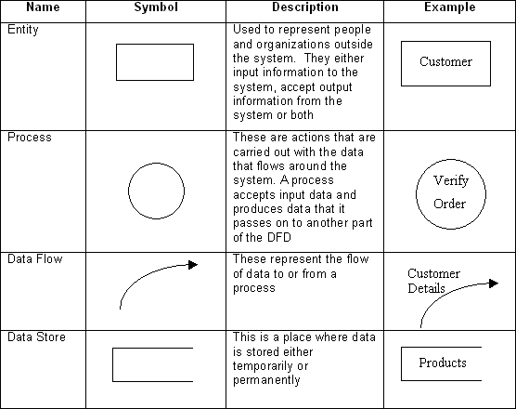

#### Fig 3.1: Data Flow Diagram Symbols

**3.1.1 DFD LEVEL0**

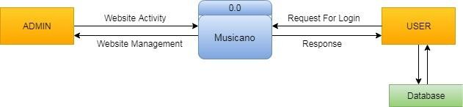

**Fig 3.2: 0 Level DFD**

* + 1. **DFD LEVEL 1**

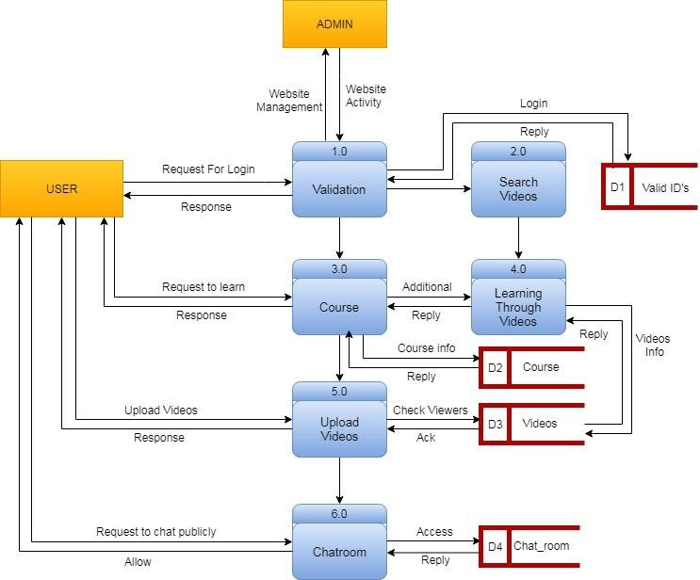

**Fig 3.3: 1 Level DFD**

* + 1. **DFD LEVEL 2 PROCESS 3 (Course)**

**Fig 3.4: 2 Level DFD(Process 3)**

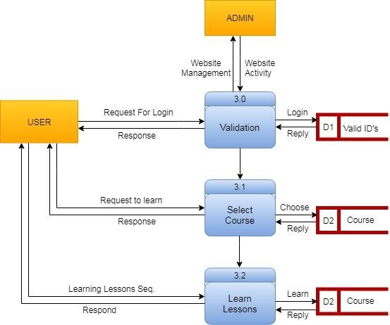

* + 1. **DFD LEVEL 2 PROCESS 6 (Chat room)**

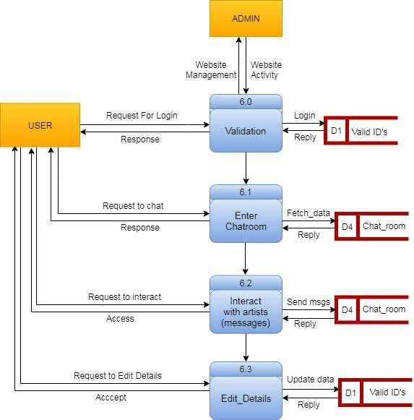

**Fig 3.5: 2 Level DFD (Process 6)**

In 0 level DFD, all type of user can fill their login details to get in MUSICANO (project) and then all of them can access the info about the instruments.

In 1 level DFD, the admin can login by providing the valid username and password. After, that admin can create id and password for the beginners and artists.

In 2 Level DFD (Process 3), the beginners can select course and through videos.

In 2 Level DFD (Process 6), the beginners and artists can communicate through chat room and can edit their details.

### Entity Relationship Diagram(ER-Diagram)

An entity-relationship diagram (ERD) is a graphical representation of an information system that shows the relationship between people, objects, places, concepts or events within that system. An ERD is a [data modeling](http://searchdatamanagement.techtarget.com/definition/data-modeling) technique that can help define business processes and can be used as the foundation for a [relational database.](http://searchsqlserver.techtarget.com/definition/relational-database)

While useful for organizing [data](http://searchdatamanagement.techtarget.com/definition/data) that can be represented by a relational structure, an entity-relationship diagram can't sufficiently represent semi-structured or [unstructured](http://searchbusinessanalytics.techtarget.com/definition/unstructured-data) [data,](http://searchbusinessanalytics.techtarget.com/definition/unstructured-data) and an ERD is unlikely to be helpful on its own in integrating data into a preexisting information system.

Three main components of an ERD are the [entities](http://whatis.techtarget.com/definition/entity), which are objects or concepts that can have data stored about them, the relationship between those entities, and the [cardinality,](http://whatis.techtarget.com/definition/cardinality) which defines that relationship in terms of numbers.

#### Components of the ER Model

The three main components of the ER Model are **entities**, **attributes** and

#### relationships.

* In ERM terms, an entity is a "thing" within the organization that we want to keep information about, such as a customer, employee or course. In other words, an entity in an ERM actually refers to a table, and rows within the table are referred to as entity occurrences. Entities are represented by rectangles containing the name of the entity. Entity names must be singular and in capital letters.
* Each entity has attributes which are the properties of each entity. Attributes will be implemented as columns in the tables. Each attribute has a domain which specifies the set of possible values an attribute can have. For instance, the range of values for a telephone extension may be specify data se to integer numbers between 4000 and 4999. An attributes domain is not displayed in ER diagrams, but is recorded in the data dictionary.
* Attributes can be of various types. A composite attribute can be subdivided into smaller parts. For example, an attribute Name can be subdivided into First Name and Last Name. Attributes that cannot be subdivided are called simple attributes. First Name and Last Name are now simple attributes. Most attributes have only a single value and as such are called single valued attributes. For example, a Teacher can have only one Last Name or a Subject can have only one Subject Code. Multi-valued attributes can have more than one value. For example, a Student could have more than one Certificate or a Department may have several Extensions.
* A key attribute is an attribute that has a unique value for each entity occurrence. In other words, a key attribute is used to identify each row uniquely. For example, a Subject Code will uniquely identify each subject as not we subject scan have the same Subject Code. Key attributes are represented by underlining its name.
* A relationship is the association between entities or entity occurrences

#### 3.2.1 ER Diagram of MUSICANO:

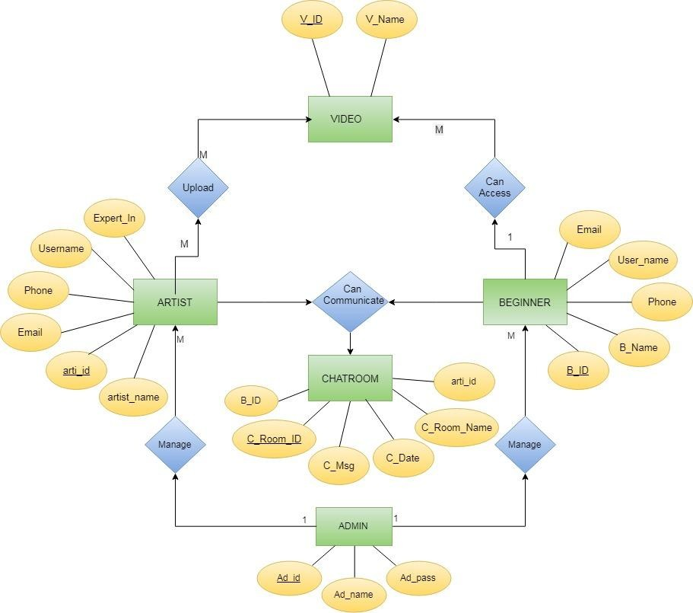

**Fig 3.6: Entity Relationship Diagram**

* 1. **Database Design**

A good database design is crucial for a high-performance application, just as an Aerodynamic body is important to a race car. If the car doesn’t have smooth lines, it will produce drag and go slower. Without optimized relationships, your database won’t perform as efficiently as possible. Thinking about relationships and database efficiency is part of normalization.

Beyond the issue of performance is the issue of maintenance—your database should be easy to maintain. This includes storing only a limited amount (if any) of repetitive data. If you have a lot of repetitive data and one instance of that data undergoes a change (such as a name change) , that change has to be made for all occurrences of the data. To eliminate duplication and enhance your ability to maintain the data, you might create a table of possible values and use a key to refer to the value. That way, if the value changes names, the change occurs only once in the master able. The reference remains the same throughout other tables.

|  |  |  |  |
| --- | --- | --- | --- |
| **Attribute** | **Type** | **Description** | **Constraints** |
| arti_id | int(11) | Id of artist | Primary Key |
| artist_name | Text | Name of artist | Not null |
| username | varchar(20) | Username of artist | Not null |
| password | varchar(9) | Password of artist | Not null |
| email | varchar(255) | Email of artist | Not null |
| address | varchar(255) | Address of artist | NULL |
| phone | varchar(10) | Phone number of artist | Not null |
| expert_in | varchar(8) | Expert in instrument | Not null |

#### Table 3.1: Artist Login

|  |  |  |  |
| --- | --- | --- | --- |
| **Attribute** | **Type** | **Description** | **Constraints** |
| beginr_id | int(11) | Id of beginner | Primary Key |
| beginr_name | Text | Name of beginner | Not null |
| user_name | varchar(20) | Username of beginner | Not null |
| password | varchar(15) | Password of beginner | Not null |
| email | varchar(255) | Email of beginner | Not null |
| phone | varchar(10) | Phone number of beginner | NULL |

**Table 3.2: Beginner Login**

|  |  |  |  |
| --- | --- | --- | --- |
| **Attribute** | **Type** | **Description** | **Constraints** |
| Ad_id | int(15) | Id of Admin | Primary Key |
| Ad_name | varchar(20) | Username of Admin | Not Null |
| Ad_pass | varchar(10) | Password of Admin | Not Null |

**Table 3.3: Admin login**

|  |  |  |  |
| --- | --- | --- | --- |
| **Attribute** | **Type** | **Description** | **Constraints** |
| chatid | int(11) | Id of chat | Primary Key |
| chat_room_id | int(11) | Id of chat room | NULL |
| chat_msg | Text | Messages sent in chat room | Not null |
| chat_date | Date | Date of chat | NULL |
| beginr_id | int(11) | Id of beginner | Not null |
| arti_id | int(11) | Id of artist | Not null |

**Table 3.4: Chatroom login**

15

Department of Computer Engineering & Applications

16

|  |  |  |  |
| --- | --- | --- | --- |
| **Attribute** | **Type** | **Description** | **Constraints** |
| V_ID | int(11) | ID of uploaded videos | Primary Key |
| Name | varchar(255) | Name of avideo | Not Null |

**Table 3.5: Upload videos**

**Chapter 4 IMPLEMENTATION &USER INTERFACE**

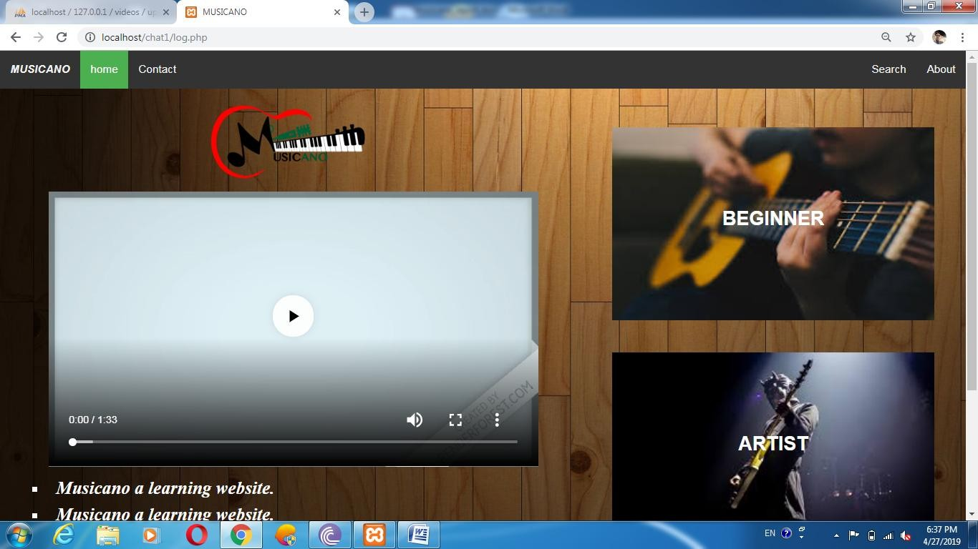

#### Fig 4.1: Home

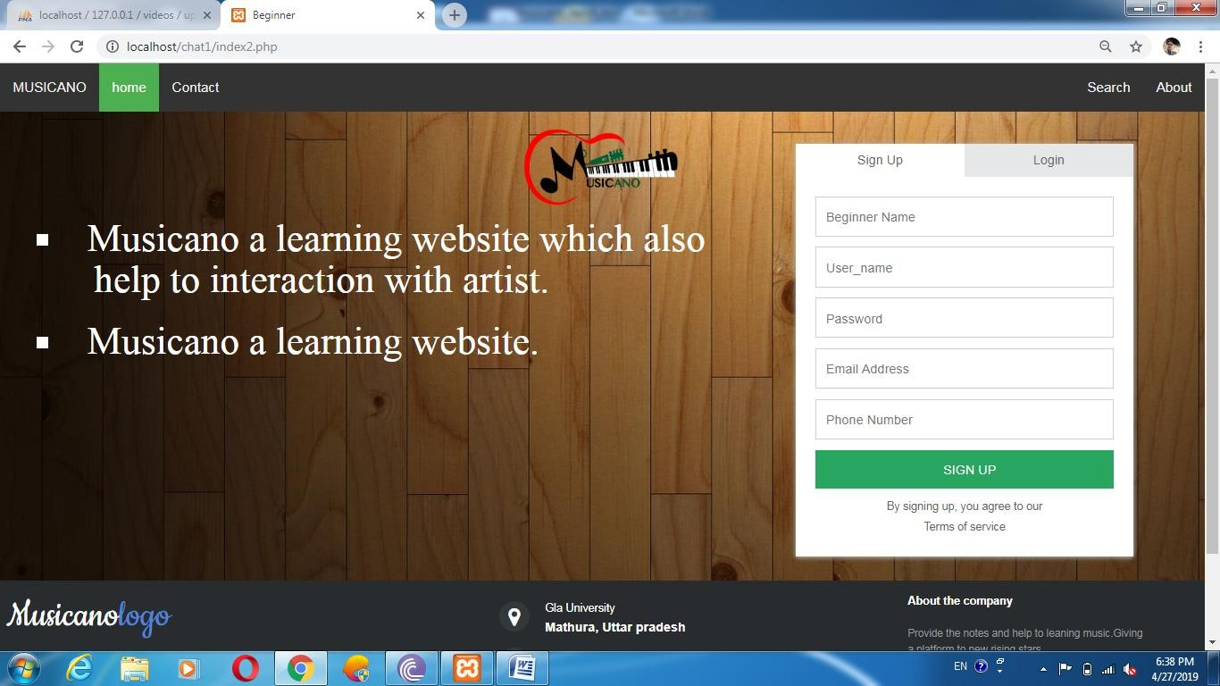

**Fig 4.2: Beginner’s Registration**

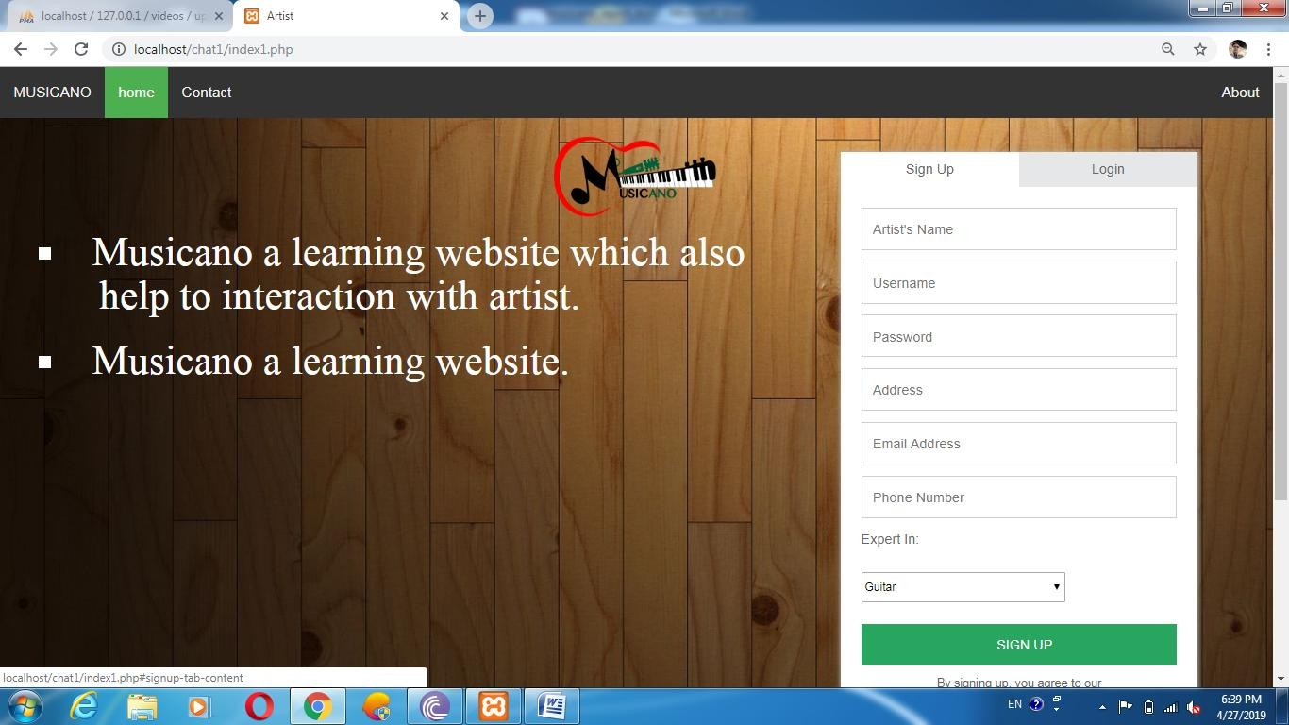

**Fig 4.3: Artist’s Registration**

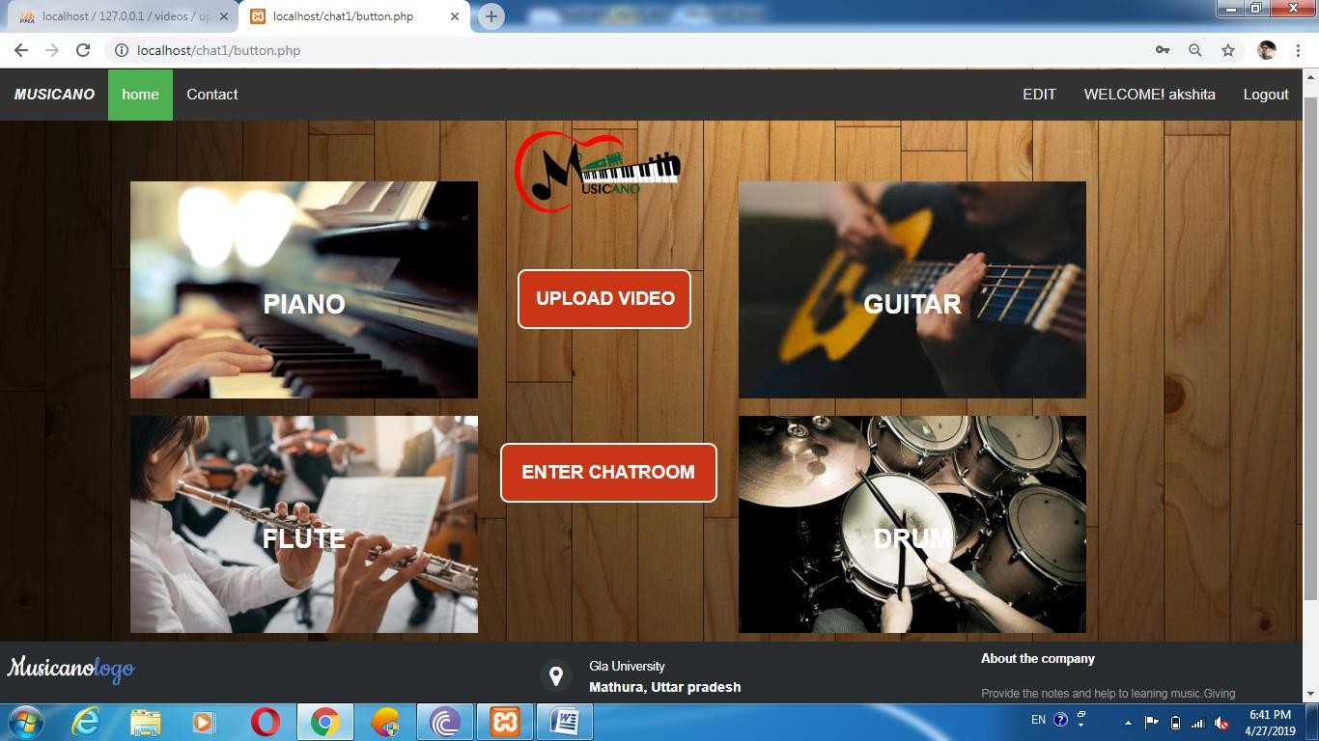

**Fig 4.4: Beginner’s Page**

20

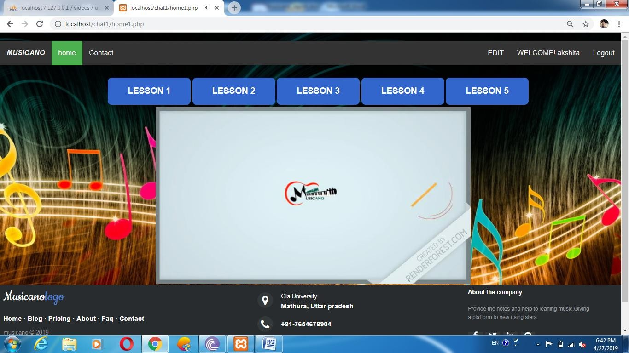

**Fig 4.5: Guitar Lesson page**

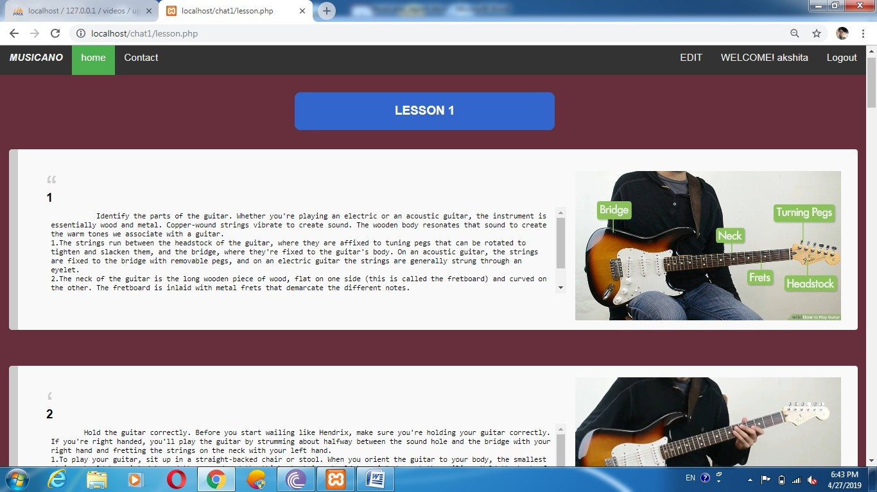

**Fig 4.6: Lesson Page**

21

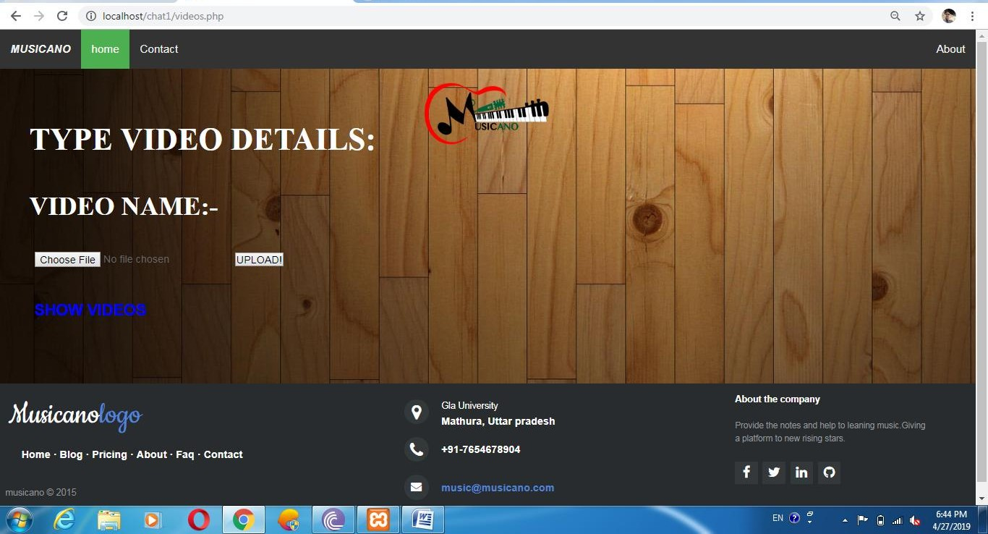

**Fig 4.7: Uploading videos page**

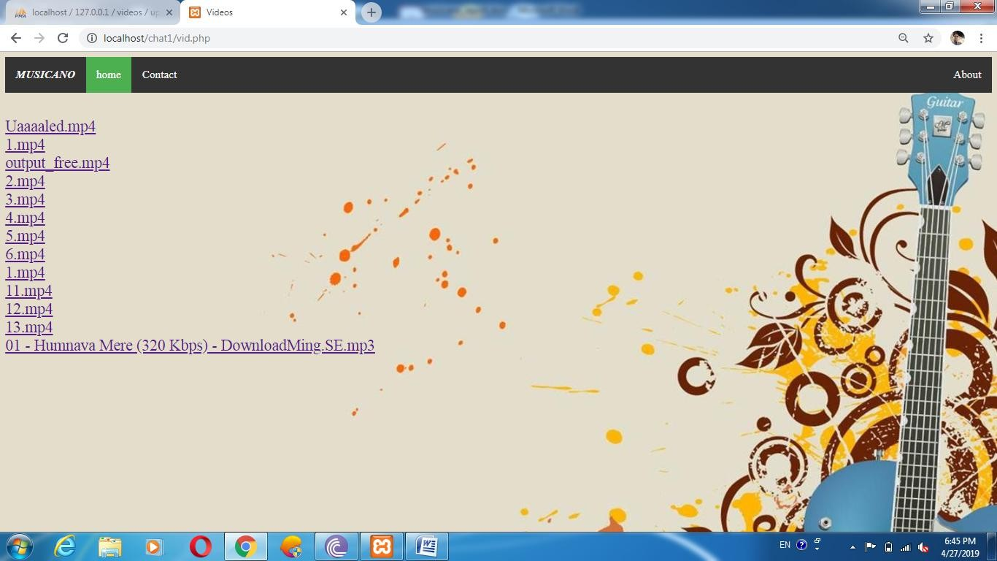

**Fig 4.8: Uploaded videos page**

22

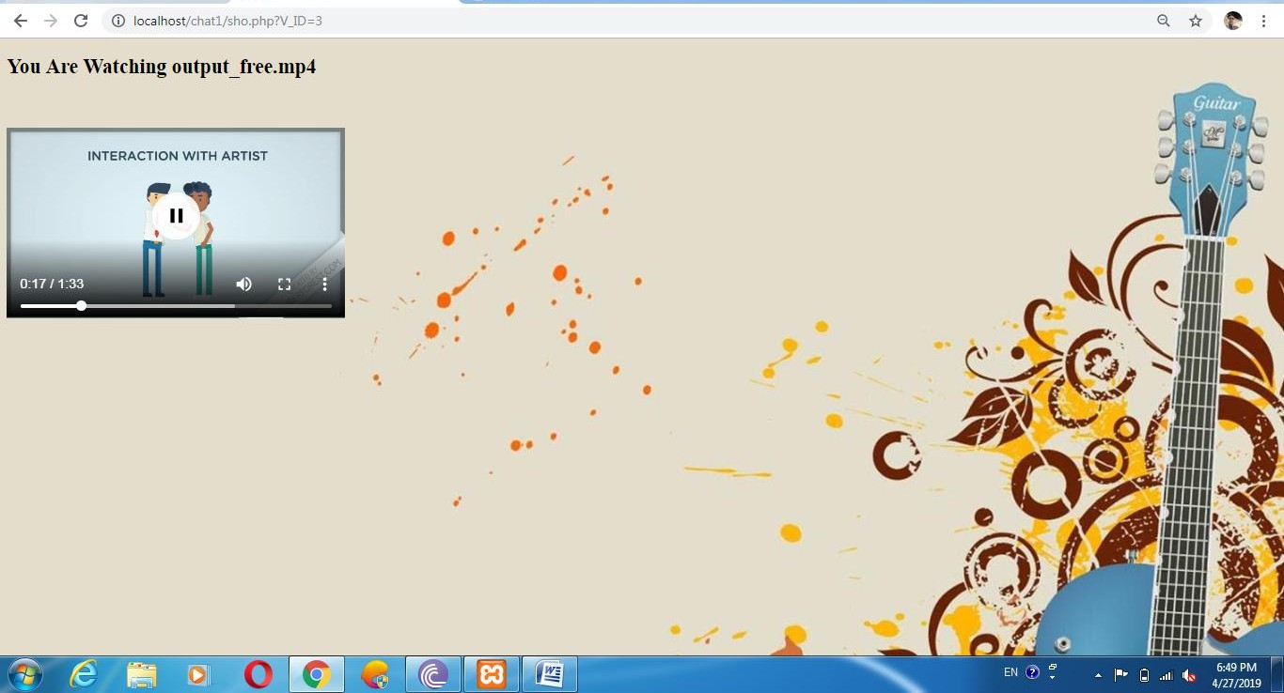

**Fig 4.9: Watch videos page**

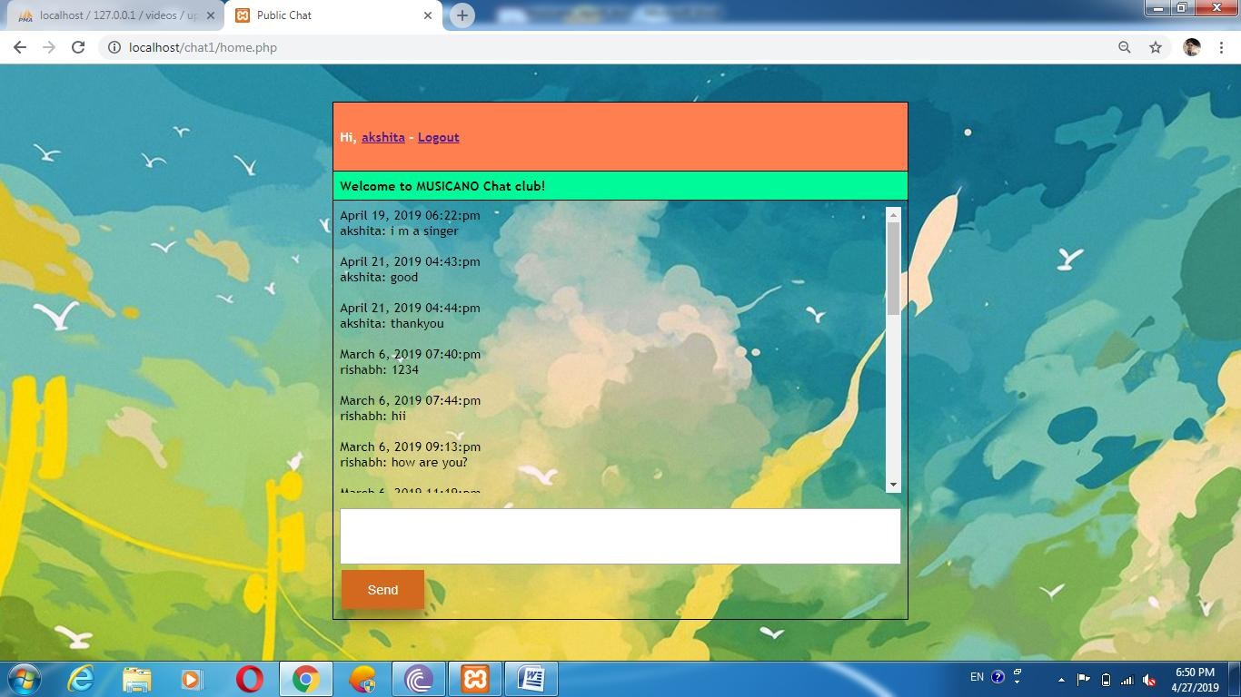

**Fig 4.10: Chat room page**

23

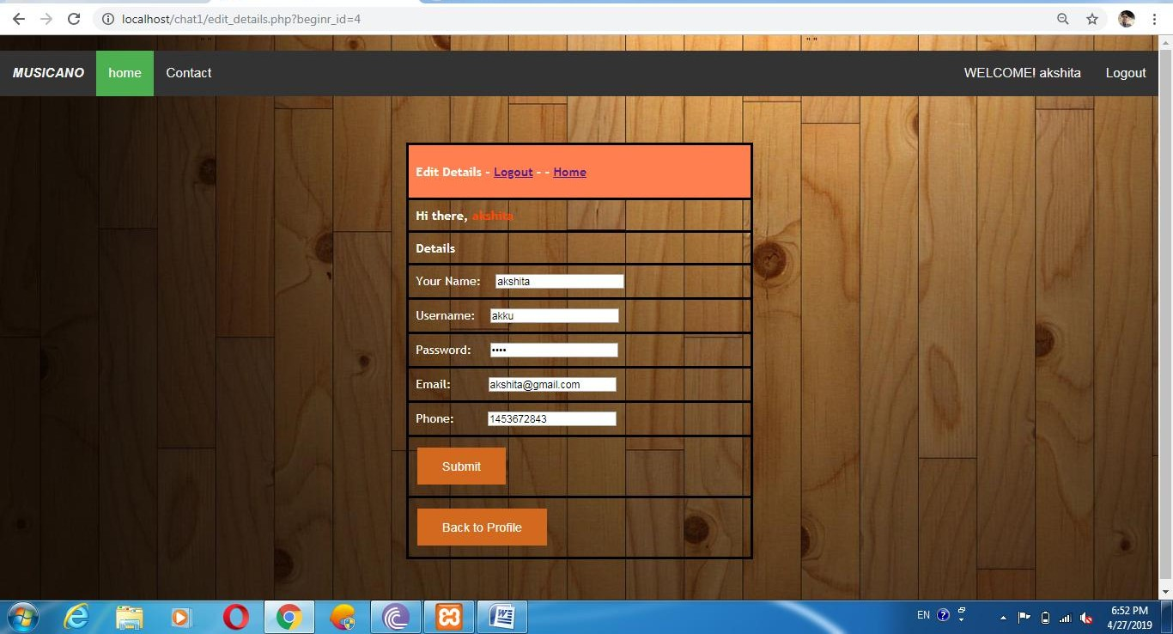

**Fig 4.11: Edit Details page**

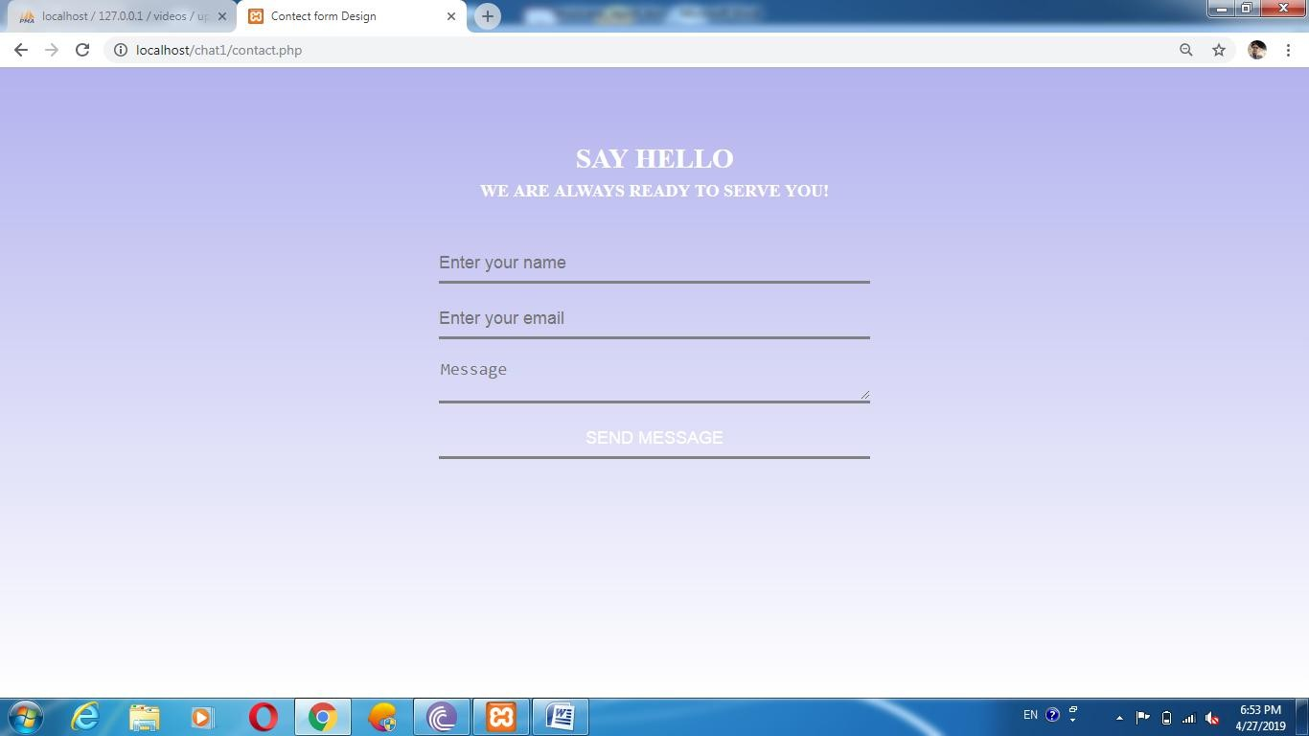

**Fig 4.12: Contact us page**

24

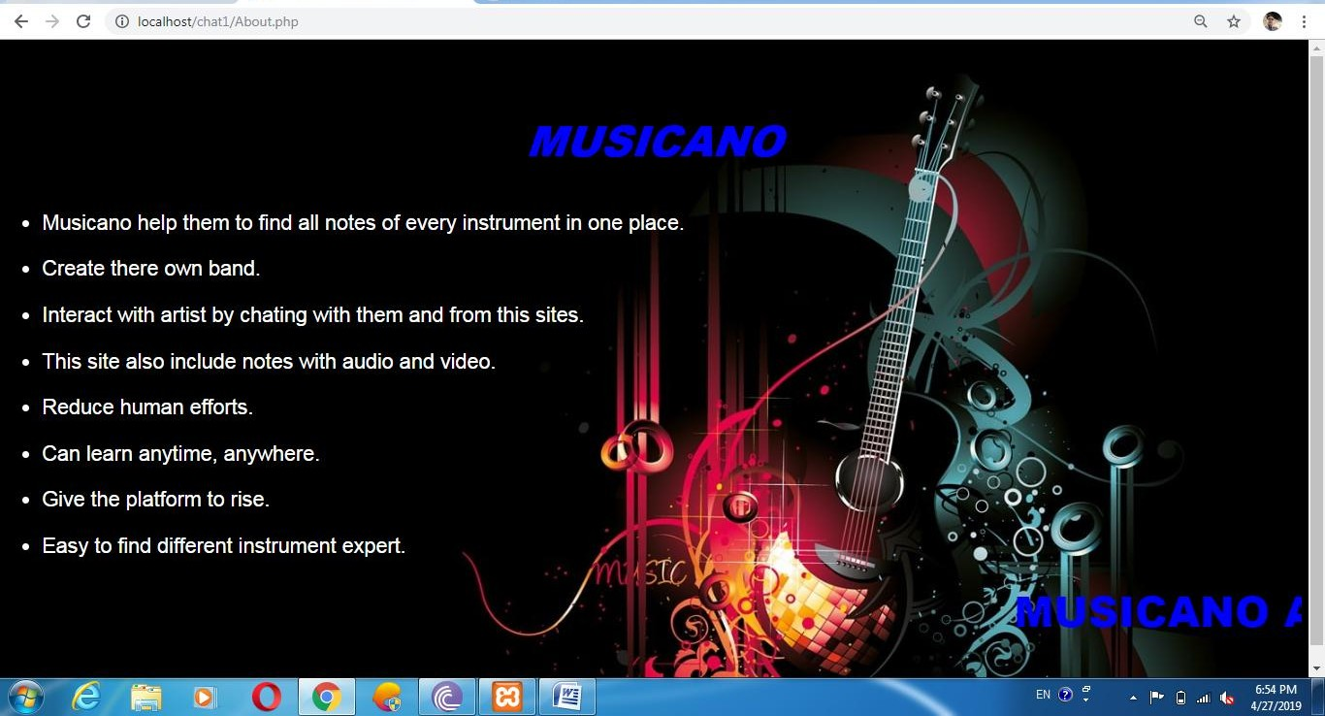

**Fig 4.13: About us page**

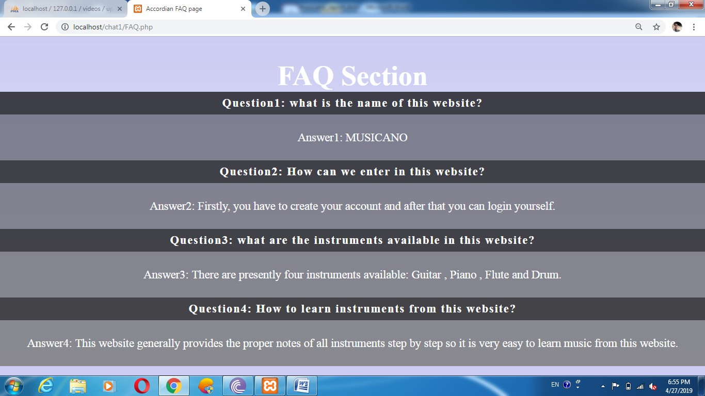

**Fig 4.14: FAQ page**

25

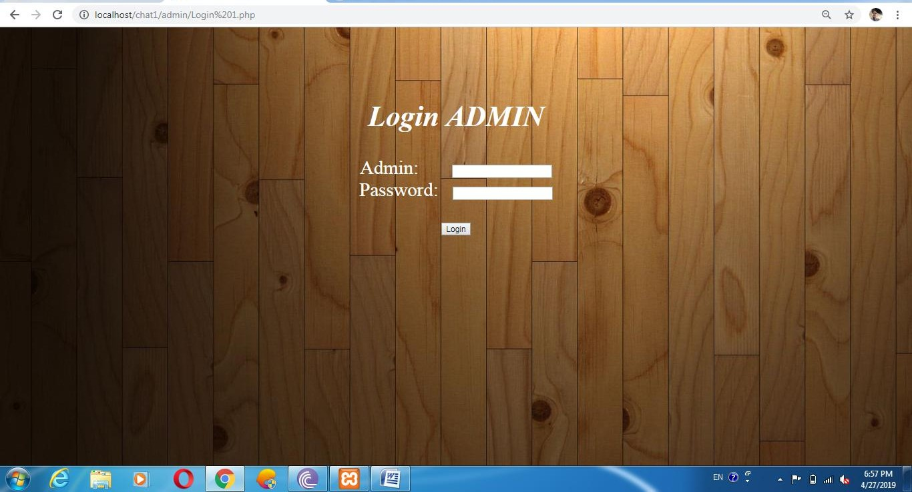

**Fig 4.15: Admin Login**

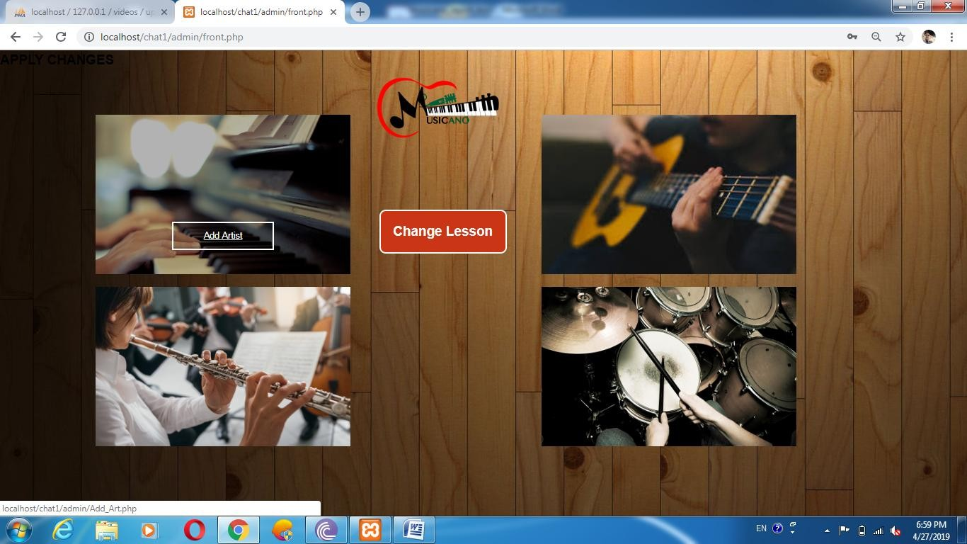

**Fig 4.16: Admin page**

26

**Chapter 5 SOFTWARE TESTING**

**5.1 Testing**

* + - Software testing is the process of executing a program with intension of finding errors in the code. It is a process of evolution of system or its parts by manual or automatic means to verify that it is satisfying specified or requirements or not.
    - Generally, no system is perfect due to communication problems between user and developer, time constraints, or conceptual mistakes by developer.
    - To purpose of system testing is to check and find out these errors or faults as early as possible so losses due to it can be saved.
    - Testing is the fundamental process of software success.
    - Testing is not a distinct phase in system development life cycle but should be applicable throughout all phases i.e. design development and maintenance phase.
    - Testing is used to show incorrectness and considered to success when an error is detected.

### Objectives of Software Testing

* **Software Quality Improvement:** The computer and the software are mainly used for complex and critical applications and a bug or fault in software causes severe losses. So a great consideration is required for checking for quality of software.

#### Verification And Validation:

* + - * Verification means to test that we are building the product in right way .i.e. are we using the correct procedure for the development of software so that it can meet the user requirements.
      * Validation me to check whether we are building the right product or not.

27

* **Software Reliability Estimation:** The objective is to discover the residual designing errors before delivery to the customer. The failure data during process are taken down in order to estimate the software reliability.

### 5.3 Principles of Software Testing

* All tests should be traceable to end user requirements.
* Tests should be planned long before testing begins.
* Testing should begin on a small scale and progress towards testing in large.
* To be most effective testing should be conducted by an independent third party.

The primary objective for test case design is to derive a set of tests that has the highest lively hood for uncovering defects in software. To accomplish this objective two different categories of test case design techniques are used. They are:

* White box testing.
* Black box testing.

#### 5.3.1 White-box testing:

White box testing focuses on the program control structure. Test cases are derived to ensure that all statements in the program have been executed at least once during testing and that all logical conditions have been executed.

#### 5.3.2 Block-box testing:

Black box testing is designed to validate functional requirements without regards to the internal workings of a program. Black box testing mainly focuses on the information domain of the software, deriving test cases by partitioning input and output in a manner that provides through test coverage. Incorrect and missing functions, interface errors, errors in data structures, error in function all logic are the errors falling in this category.

28

### 5.4 Testing fundamentals

Testing is a process of executing program with the intent of finding error. A good test case is one that has high probability of finding an undiscovered error. If testing is conducted successfully it uncovers the errors in the software. Testing cannot show the absence of defects, it can only show that software defects present.

### 5.5 Testing Information flow:

Information flow for testing, flow the pattern. Two class of input provided to test the process. The software configuration includes a software requirements specification, a design specification and source code.

Test configuration includes test plan and test cases and test tools. Tests are conducted and all there suits are evaluated. That is test results are compared with expected results. When erroneous data are uncovered, an error is implied and debugging commences.

29

This was the first considerably large and important project undertaken by me during my BCA course. It was an experience that changed the way I perceived project development. The coding could not best art before the whole system was completely finalized. Even then there were so many changes required and the coding needed to be changed. I attribute this to inadequate information gathering from the user. Though there were many meetings with the user and most of the requirements were gathered, a few misinterpretations of the requirements still crept in. It made me realize how important the systems analysis phase is. The project is a classic example, that learning of concepts needs to be supplemented with application of that knowledge.

On the whole it was a wonderful experience developing **MUSICANO** and I would have considered my education in complete without undertaking such a project which allowed me to apply all that I have learnt and tried to develop a project that can be useful for police and parents to find their child more easily and efficiently. It is developed in PHP so that it can be accessed very easily and at any time. The system will be capable of providing information about missing children and NGO’s to the users within a given time frame with no errors and the system will be available and operational all the time. The system is developed with an aim of usability so that it is an easy to use system that requires the least amount of user input possible. For using this system general computer knowledge is enough. An easy well-structured module will show the correct path to reach the destination. Users will be authenticated to ensure that no unauthorized users gain access to private information.

30

To develop this web application of MUSICANO, we used PHP for Front End and SQL Server 2014 for Back End (Database). We take some knowledge towards automation system from some books that are given below:

References:

[1]. [www.w3schools.com/php.net](http://www.w3schools.com/php.net)

[2]. [www.stackoverflow.com](http://www.stackoverflow.com/)

[3]. [www.php.net-tutorial.com](http://www.php.net-tutorial.com/)

[4]. [www.w3schools.com/css](http://www.w3schools.com/css)

31